* Active layers (nactive or pactive) show nmos or pmos diffusion areas (n+, P+)
* Active Contacts provide a connection between the Metal layer and the Active layer.
* N-select: Used to distinguish nmos from pmos
* P-select: Same story but for pmos
* Our silicon substrate is P-type. Therefore, to create pmos we need to create nwell first.

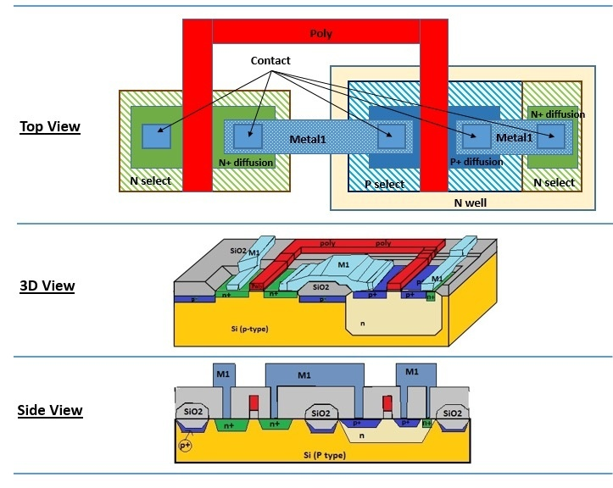

This is what you will see in Cadence layout view

Inverter